**Admin Guide - Creating Custom Application Types**

Table of Contents

Steps to Extend Government CDM by creating new application types 1

1. Create a New Solution 1

2. Create New Custom Table 2

3. Customizations in New Table 3

4. Update Polymorphic lookup (msgov_ApplicationRecordTypeId) in “Application” Table 5

5. “Application” Table changes 6

6. Add record to “Application Type” table 7

7. Process/Workflow changes 8

8. JavaScript Web Resource changes 10

Steps to Extend Government Portal by adding new application type entity: 11

1. Create New portal form 11

2. Create Portal components 11

3. Create Table permissions 12

References 12

Steps to send post request in Postman. 12

Steps to Extend Government CDM by creating new application types:

1. Create a New Solution:

For Reference: [Create a solution in Power Apps - Power Apps | Microsoft Docs](https://docs.microsoft.com/en-us/power-apps/maker/data-platform/create-solution)

Create new solution in the environment. **E.g.: ‘Vehicle Permit Solution’**.

Navigate to ***Solutions -> New Solution***.

1. Create New Custom Table

For Reference: [Create a custom table (contains video) - Power Apps | Microsoft Docs](https://docs.microsoft.com/en-us/power-apps/maker/data-platform/data-platform-create-entity)

1. Create a new Entity with essential fields. E.g.: Created a ‘**Vehicle Permit’** Entity as shown below.

Navigate to ***Solutions -> Vehicle Permit Solution -> Add Table***

**Note**: Enable Notes while creating entity.

1. Create New Columns in this entity. These columns are the “Questions” which will be available Application for this Application Type.

For Reference [How to create and edit columns for Microsoft Dataverse(contains video) - Power Apps | Microsoft Docs](https://docs.microsoft.com/en-us/power-apps/maker/data-platform/create-edit-fields)

1. Customizations in New Table

Below customizations are required to be done for the table created in step 2:

* 1. Design “Information” main form with custom columns.

Navigate to ***Solutions -> Vehicle Permit Solution -> Tables ->Vehicle Permit -> Forms -> Information (Main form)***

For Reference:[Create, edit, or configure forms using the model-driven form designer - Power Apps | Microsoft Docs](https://docs.microsoft.com/en-us/power-apps/maker/model-driven-apps/create-and-edit-forms)

* 1. Create “Quick view form” with relevant attributes.

Navigate to ***Solutions -> Vehicle Permit Solution -> Tables ->Vehicle Permit -> Forms -> Add form (In ribbon) -> Quick View Form***

1. Update Polymorphic lookup (msgov_ApplicationRecordTypeId) in “Application” Table

A Polymorphic lookup (msgov_ApplicationRecordTypeId) is already available in Application Table. The new table must be added in this Polymorphic lookup. This can not be done directly from Powerapps. It requires a WEB API call to be send to Dataverse using Postman

Follow below steps to Add new table created in step 2 (Vehicle Permit entity) to Polymorphic lookup (msgov_ApplicationRecordTypeId) in Application Table:

* 1. Use ***Postman*** to send Web API requests to Power Platform. Please refer link - [Use Postman with Microsoft Dataverse Web API (Developer Guide for Dataverse) - Power Apps | Microsoft Docs](https://docs.microsoft.com/en-us/powerapps/developer/data-platform/webapi/use-postman-web-api) for the same.

Refer the steps  to connect Postman and test connection.

Refer MS docs [Use multi-table lookup columns (Microsoft Dataverse) - Power Apps | Microsoft Docs](https://docs.microsoft.com/en-us/powerapps/developer/data-platform/webapi/multitable-lookup).

**Request :** POST [OrganizationUrl]/api/data/v9.0/RelationshipDefinitions

* 1. Below is the Sample Payload for reference. Copy and paste below Payload in ***Postman(Refer step a)***.

Update highlighted values for the columns as per your new table.

{

"SchemaName": "msgov_msgov_application_msgov_vehiclepermitapplication_msgov_ApplicationRecordTypeId", ***-----> Replace with custom schema name***

"@odata.type": "Microsoft.Dynamics.CRM.OneToManyRelationshipMetadata",

"CascadeConfiguration": {

"Assign": "NoCascade",

"Delete": "RemoveLink",

"Merge": "NoCascade",

"Reparent": "NoCascade",

"Share": "NoCascade",

"Unshare": "NoCascade"

},

"ReferencedEntity": "cr71c_vehiclepermit", ***-----> Replace with new entity schema name***

"ReferencingEntity": "msgov_application",

"Lookup": {

"AttributeType": "Lookup",

"AttributeTypeName": { "Value": "LookupType" },

"Description": {

"@odata.type": "Microsoft.Dynamics.CRM.Label",

"LocalizedLabels": [

{

"@odata.type": "Microsoft.Dynamics.CRM.LocalizedLabel",

"Label": "Checkout Polymorphic Lookup Attribute",

"LanguageCode": 1033

}

],

"UserLocalizedLabel": {

"@odata.type": "Microsoft.Dynamics.CRM.LocalizedLabel",

"Label": "Checkout Polymorphic Lookup Attribute",

"LanguageCode": 1033

}

},

"DisplayName": {

"@odata.type": "Microsoft.Dynamics.CRM.Label",

"LocalizedLabels": [

{

"@odata.type": "Microsoft.Dynamics.CRM.LocalizedLabel",

"Label": "Vehicle Permit", ***à Change Label names as per New table***.

"LanguageCode": 1033

}

],

"UserLocalizedLabel": {

"@odata.type": "Microsoft.Dynamics.CRM.LocalizedLabel",

"Label": "Vehicle Permit", ***à Change Label names as per New table***.

"LanguageCode": 1033

}

},

"SchemaName": "msgov_ApplicationRecordTypeId",

"@odata.type": "Microsoft.Dynamics.CRM.LookupAttributeMetadata"

}

}

1. “Application” Table changes

For Reference: [How to create a solution in Dynamics 365 Customer Engagement (on-premises) | Microsoft Docs](https://docs.microsoft.com/en-us/dynamics365/customerengagement/on-premises/customize/create-solution?view=op-9-1)

* 1. Add “**Application**” table to solution created in step 1 (vehicle permit solution).
  2. Update **Quick View control** in ***Questionnaire*** Tab of **Main form** with newly created **Quick View Form** of child table (in step 3)
     1. Add **Information** **Main form** to new solution created.

Navigate to ***Solutions -> Vehicle Permit Solution -> Tables -> Application -> Forms -> Add Subcomponents (in ribbon) -> Select Information form(Main form type)***

* + 1. Navigate to **Questionnaire** tab and select **Quick view** form created.

1. Add record to “Application Type” table
   1. Navigate to **Apps -> Government Services (Model Driven App) -> Application type.**
   2. Create a new **Application Type** Record by giving Name and Code Number.

* 1. **Note:** It is mandatory to associate this application type to either service or program to create applications under this type.

**Steps to associate:** Navigate to Related tab and select either Program or service.

Click on Add existing Program/Service and select appropriate record.

1. Process/Workflow changes

Update existing process/workflow to create child table record based on **Application Type**.

* 1. Add existing process with name - ***Create Application Child Entity Record Based on Application Type*** to solution created in step 1 (Vehicle Permit Solution)

Navigate to ***Solutions -> Vehicle Permit Solution -> Processes -> Add Existing (In ribbon) -> Process -> Create Application Child Entity Record Based on Application Type***

* 1. Deactivate the workflow.
  2. Add condition in the workflow to check for **Application Type** and then create record (of new entity created in step 2 – Vehicle Permit). Below step should be added as last step in the process.

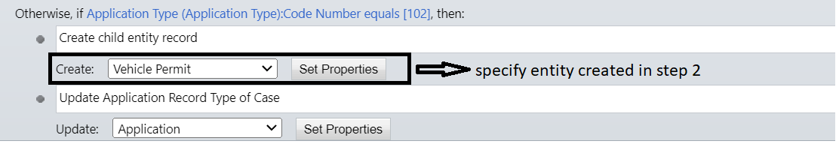

* 1. Click on Set Properties beside ***Create Vehicle Permit*** entity.

Name: {Subject(Application)}-{Application Type(Application)}

* 1. Click on Set Properties beside ***Update Application*** entity.

* 1. Activate the workflow.

1. JavaScript Web Resource changes

Update JavaScript Web resource to add condition to check newly created **ApplicationType** and open corresponding **Questionnaire**

* + 1. Add existing web resource - **msgov_UpdateApplicationQuestionnaire** to solution

Navigate to ***Solutions -> Vehicle Permit Solution -> Web Resources -> Add Existing (In ribbon) -> Process -> msgov_UpdateApplicationQuestionnaire***

* + 1. Edit Web resource in classic view.
    2. Navigate to Javascript function with name - ***ShowPanel***(result)
    3. Changes needs to be done in if condition:
       1. Add condition as last condition for the first if statement and assign values as below.

*else if (result.msgov_ApplicationType.msgov_codenumber == "102") {*

*entityName = "cr71c_vehiclepermit";*

*formId = "77872c-38e8-4857-aaef-49ad28291b44";*

*}*

**Note: Below steps will help to get custom entity formid**

entityName = "schema name of child table created";

formId = "guid of Main form (customized in step 2)";

Steps to get Guid of Main form.

Navigate to ***Solutions -> Vehicle Permit Solution -> Tables ->Vehicle Permit -> Forms -> Information (Main form)***

* + - * 1. Copy browser URL and paste it in notepad and take formid as below.



Steps to Extend Government Portal by adding new application type entity:

Create New portal form

Design “**Vehicle Permit Portal Form**” main form with custom attributes.

Navigate to ***Solutions -> Vehicle Permit Solution -> Tables ->Vehicle Permit -> Forms -> Add form (In ribbon) -> Main Form***

Create Portal components

* + 1. Navigate to ***Apps -> Portal Management.***
    2. Create below Basic Forms: Navigate to Basic forms in left navigation

Refer MSDocs - <https://docs.microsoft.com/en-us/powerapps/maker/portals/configure/entity-forms#add-a-form-to-your-portal>

for creating basic forms.

Questionnaire Form:

Name: Gov/Questionnaire/<<entity schema name>>

Mode : Edit

On Success settings: Redirect to Web Page.

Append Existing Query String : True

Web Page : Gov/ApplicationSuccessPage

Add additional settings to enable notes.

Click on Advanced settings in Additional Settings tab and add below configurations for submit button.

View Questionnaire Form:

Name: Gov/Questionnaire/View/<<entity schema name>>

Mode: Read-only

Record source type : Query string.

Website – Select Government services.

1. Create Table permissions

Create below table permissions.

***Name: Gov - <<Entity Name>> Entity Permissions***.

Previliges : Read/Write/Create/Append/Append To

Web Roles : Administrations & Authenticated Users

Access type: Parent.

Parent Table Permission: Gov – Applications Entity Permissions

***Name: Gov - <<Entity Name>> Note***

Previliges : Read/Create/Append/AppendTo

Access Type: Parent

Table Name: Note

Parent Table Permission: Select Table Permission created in above step.

References:

### Steps to send post request in Postman.

Download Postman app from this link. (https://www.getpostman.com/apps)

* + - 1. Open downloaded Postman app from desktop.
      2. Set up environment:
         1. Click on environments in side navigation
         2. Click on + button
         3. Create new environment by entering proper values. Refer this link for more details ([Set up a Postman environment (Microsoft Dataverse for Apps) - Power Apps | Microsoft Docs](https://docs.microsoft.com/en-us/power-apps/developer/data-platform/webapi/setup-postman-environment))

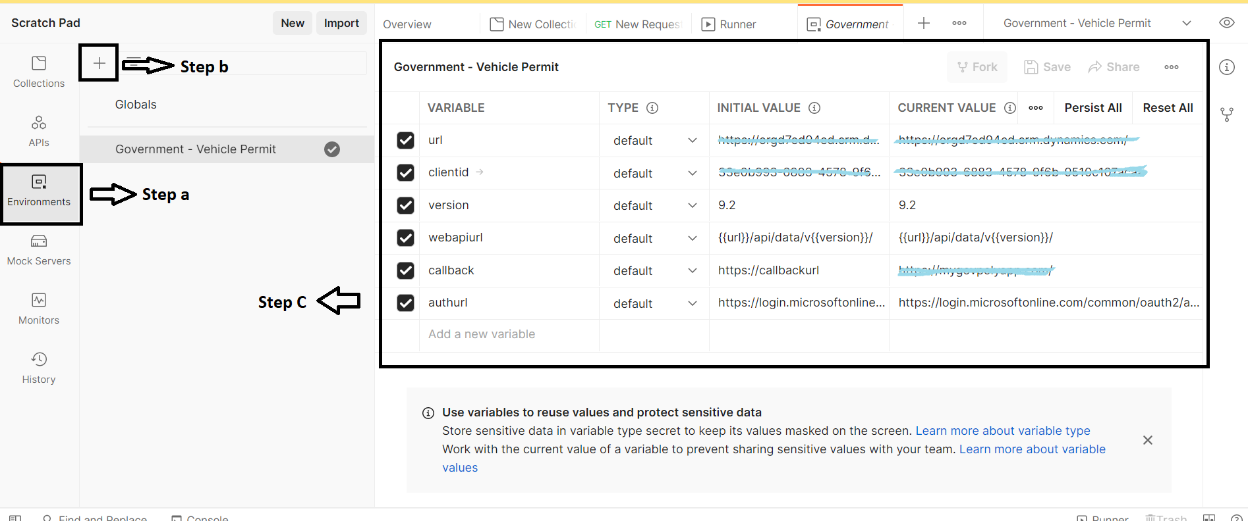

* + - * 1. Steps to Register app in application registration and get client Id:

Follow this link to Register app in application registration and get client id and callback url (Redirect url): [Tutorial: Register an app with Azure Active Directory (Microsoft Dataverse) - Power Apps | Microsoft Docs](https://docs.microsoft.com/en-us/power-apps/developer/data-platform/walkthrough-register-app-azure-active-directory)

Enable access token for implicit grant and hybrid flows (Appregistrations -> Authentication)

* + - * 1. Generate an access token and test your connection to the environment using steps in the link - <https://docs.microsoft.com/en-us/power-apps/developer/data-platform/webapi/setup-postman-environment#generate-an-access-token-to-use-with-your-environment>